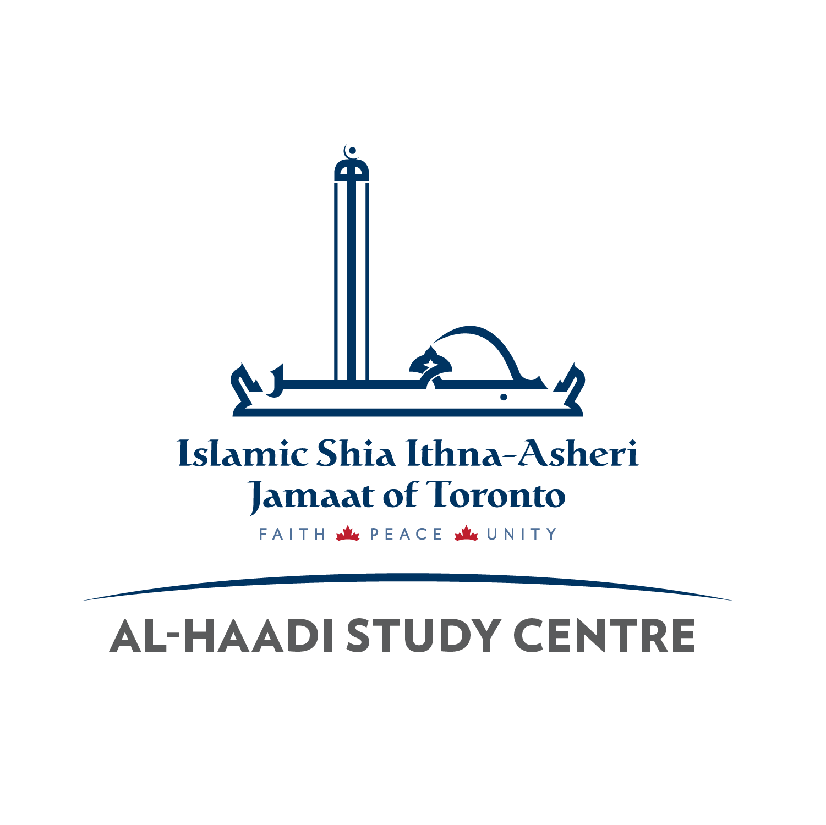
New Student Registration – Al-Haadi Study Centre
Al-Haadi Fees | 1 Child | 2 Children | Each Additional Child
 | $175 | $275 | +$100 for each child

Please fill out the following form and email it to registration@al-Haadi.ca. Instructions:

- Please download the Qur’an Level Placement Test from our website (www.al-haadi.ca) and test your child (or ask someone to test them) and let us know their level (from 0 – 10) in the appropriate section below. If you can’t test them, we cannot place them in their correct Qur’an class and they should go to the testing room on the first day (the email you will receive will have details of this.). Please note, if this form is being filled out by other than a parent, then we will ask the person to come in the first day and show proof of legal guardianship as, by law, you cannot register someone else’s child.
- Please download the ISSC Handbook for Parents and Students from our website (www.al-haadi.ca) and agree to the terms and conditions below or we cannot register your child.
- Please note at least one email address below MUST be gmail for google classroom.

Father’s or Legal Guardian’s First and Last Name: |  |  |  |  |  | Mother’s or Legal Guardian’s First and Last Name:
Father’s Cell Phone: |  |  |  |  |  | Mother’s Cell Phone:
Emergency Contact Name: |  |  |  |  |  | Emergency Contact Telephone:
Mailing address (for your receipt):
Street No/Name/Apt:
City:
Postal Code:

Home/Primary Phone (the number we will try first):

Primary Email (for Madrasah communication):

Email for on-line class access (must be gmail):

Child’s First Name | Child’s Last Name | Date of Birth  YYYY-MM-DD |  |  | Child’s Emai  (parents gmail will be used if not available)l |  | Child’s Qur’an Level (on TEST*) | Does the child have any allergies?  Provide Details.
Can you pay full fees? YES/ NO
(PLEASE NOTE IF YOU CANNOT PAY FULL FEES, FILL THE SUBSIDY FORM ON OUR WEBSITE AND EMAIL IT TO US ALSO).

Terms and Conditions for Registration:
Your signature or name typed below and date indicate you agree to the following terms and conditions for registering your child(ren) at Al-Haadi Study Centre:
A. Canada’s Anti-Spam legislation (CASL) requires we ask permission before sending email updates. By checking the box below, you give ISSC Al-Haadi permission to send you email updates.
B. I declare having read and understood the Student Insurance Agreement and Waiver Form, as it appears below, in its entirety and hereby consent to participate acknowledging the contents of Insurance Agreement Form.
C. I have downloaded the ISSC Handbook for Parents and Students from the www.al-haadi.ca website and I and my child(ren) understand and agree to abide by the policies and guidelines of ISSC Al-Haadi, including giving permission to the administration and teachers to enforce the Code of Conduct. We agree that we will pay any fines incurred if our child(ren) break anything belonging to Al-Haadi Study Centre, including damage to furniture or premises.
AL-HAADI ISLAMIC SHIA STUDY CENTRE INSURANCE AGREEMENT AND WAIVER FORM
As a condition of participating in any Islamic Shia Study Centre (ISSC) activities, I as parent/guardian of the students being registered, consent to the below:
Participating in certain activities including, but not limited to, individual and team sports, clubs or recreational activities or events held by the Student Council may increase the risk of accidents and/ or injuries. The Islamic Shia Study Centre and the Islamic Shia Ithna Asheri Jamaat of Toronto does not provide any accidental death, disability, dismemberment insurance or medical expenses on behalf of students.
I understand that certain activities at the Study Centre, including field trips, extracurricular, etc. require a minimum level of fitness and health (physical, mental and emotional) and that each person has a different capacity for participating in these activities.
I hereby agree and promise that my child, ward or self is physically able to participate and understand that the choice to participate brings with it the assumption of those risks and results which are part of these activities.
I hereby release, waive and forever discharge the Islamic Shia Study Centre (ISSC) and the Islamic Shia Ithna Asheri Jamaat (ISIJ) of Toronto, its members, agents, representatives, elected and appointed officials and assigns of and from any and all claims, demands, damages, costs, expenses, actions and causes of actions whatsoever, whether in law or equity, in respect of injury or loss. I further agree to indemnify and save harmless all of the aforesaid from and against any and all liability incurred by any of them arising as a result of, or in any way connected with the participation in these types of activities.
Signature of Applicant: ________________________
(Please write your full name if this is being emailed)
Date of this Application: __________________________
Telephone number we should contact and best time to contact if we have any questions about this application: T: ____________________ Times: _________________________

